PHASE 4 WRITEUP

I added a Unit Test Framework Project on top of the Phase Three Project named ShoppingCart.Testing.

Under this project, there is a file named **UnitTest1.cs** that consists of all the test methods needed for the project

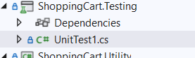

I have commented the following portion of code from ApplicationDbContext.cs so that the test methods can run



UnitTest1.cs

There is a private method named CreateDbContext() that allows us to create a DbContext needed for the test methods.

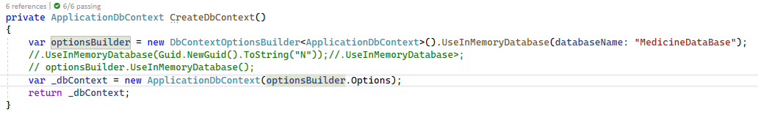

Following are the details of the test methods

1. addCategory

This method tests the addition of Category record into the Category Table. I create a test category record and add it to the table(initially empty).

I fetch the id of the record inserted and try to assert with 1, which should be the id of the first record.

The test Passes

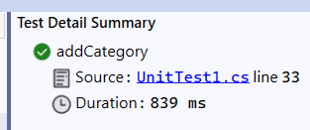

1. updateCategory

This method tests the updation of Category record. I create a Category record and save to Database.

Then the description is updated for the category record.

Then the original description and the one on the category record are matched to check if it is the same or not.

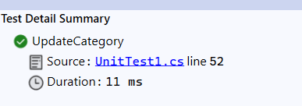

1. deleteCategory

In this method ,one Category record is added to the Table. The category record is then deleted.

The GetT method should not return any record for this, and its result is expected to be null.

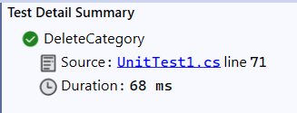

1. Add Medicine

A category record is added. Then, a medicine record is added associating the id of the Category record to it.

To validate correct addition of medicine record, the category id of the medicine record is compared with the Id of category record initially.

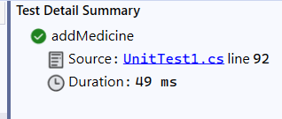

1. Update Medicine

A category record is added. Then a medicine is added associating to that category record.

The medicine record’s Price is updated and matched with the same after update operation.

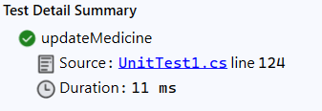

1. Delete Medicine

A category record is added. Then a medicine is added associating to that category record.

The medicine record is deleted. The GetT method should not return any record for this, and its result is expected to be null.

